 CI-CD THROUGH JENKINS USING HTTPD

CREATE AN EC2 INSTANCE USING AMAZON LINUX OS BY ALLOWING ALL TRAFFIC AND ANYWHERE IN NETWORK

* Connect the instance
* Excute the following commands.
* sudo yum update
* sudo -i ( For switching into root user )
* sudo wget -O /etc/yum.repos.d/jenkins.repo \ <https://pkg.jenkins.io/redhat-stable/jenkins.repo>
* sudo rpm --import <https://pkg.jenkins.io/redhat-stable/jenkins.io-2023.key>
* amazon-linux-extras install java-openjdk11
* java --version
* yum install jenkins -y
* systemctl enable Jenkins
* systemctl start Jenkins
* systemctl status Jenkins

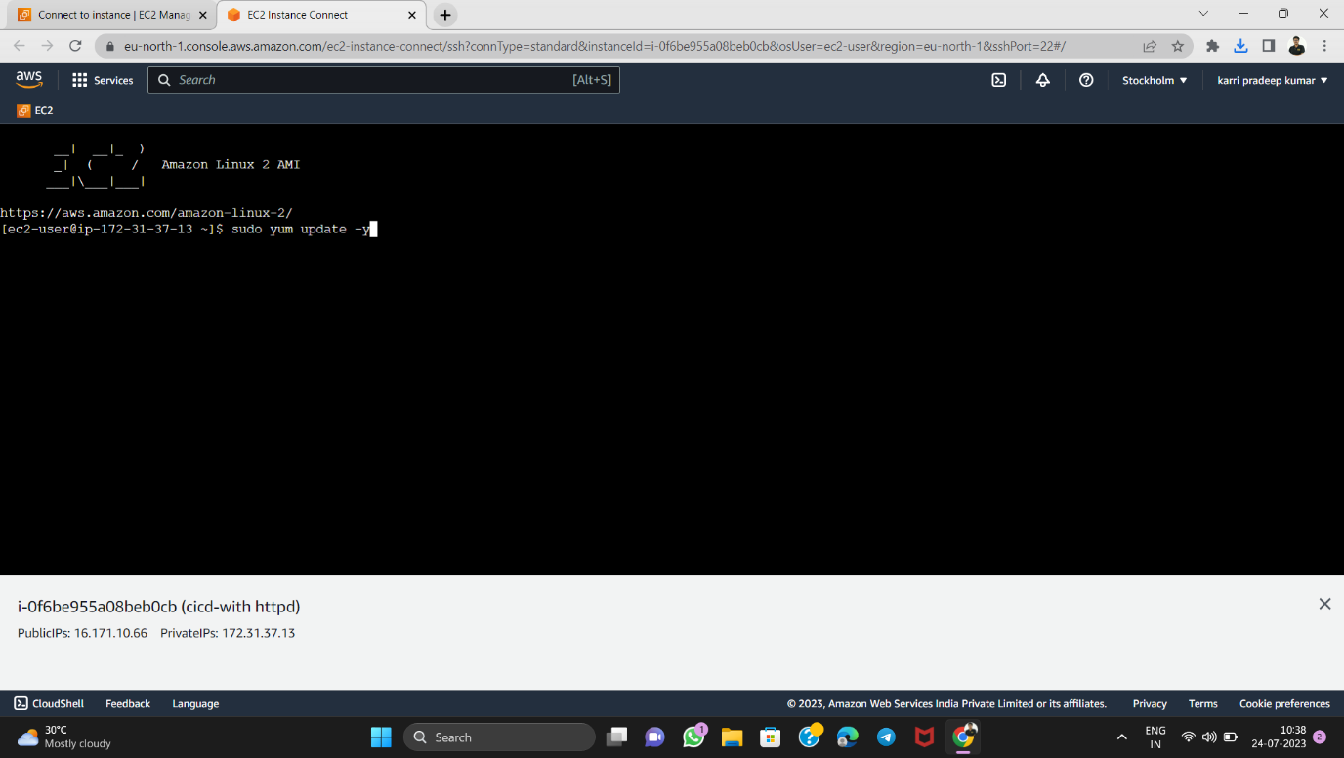

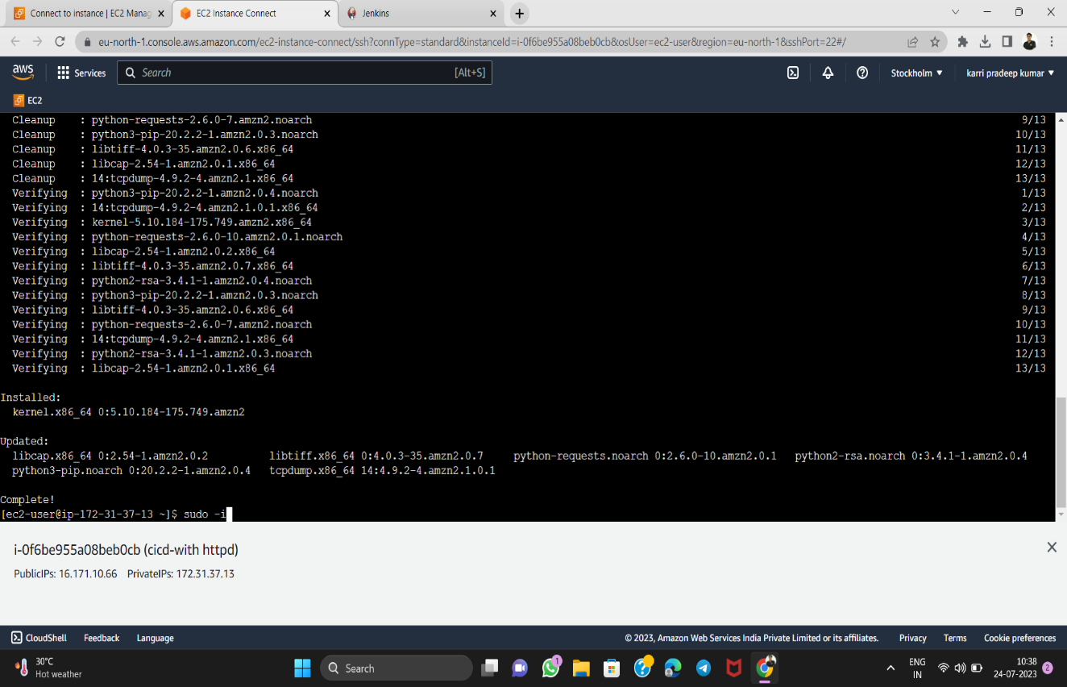

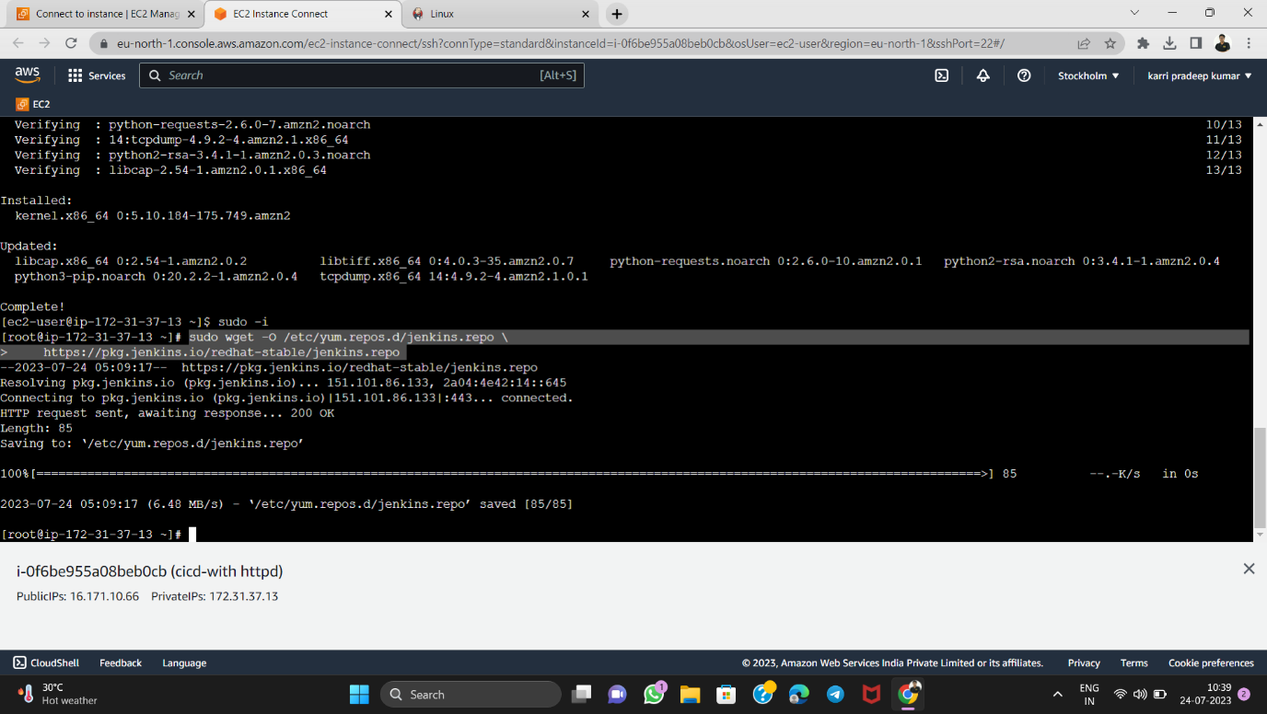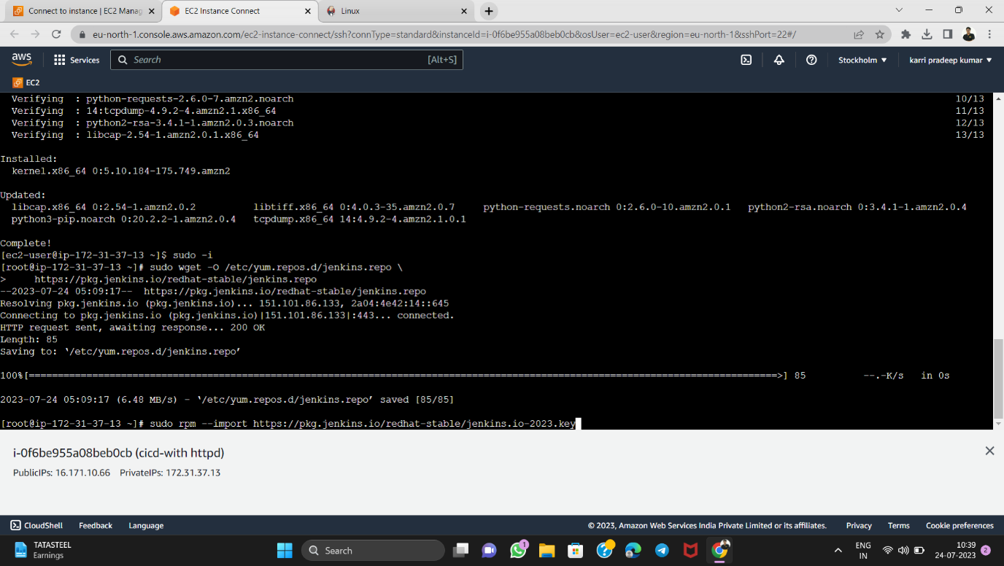

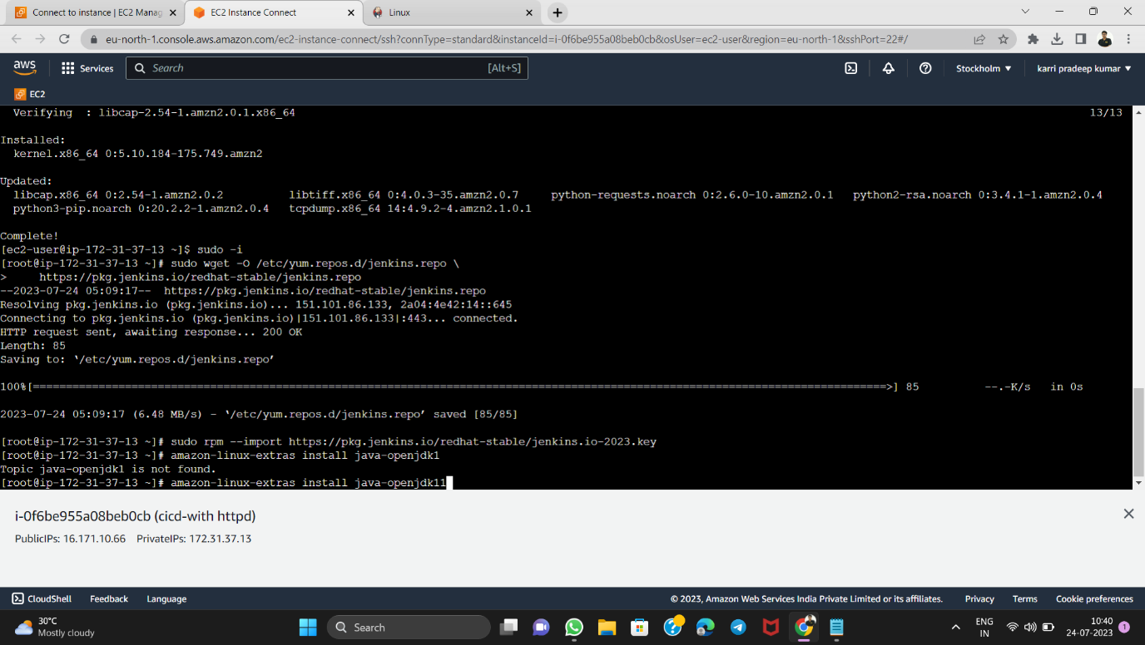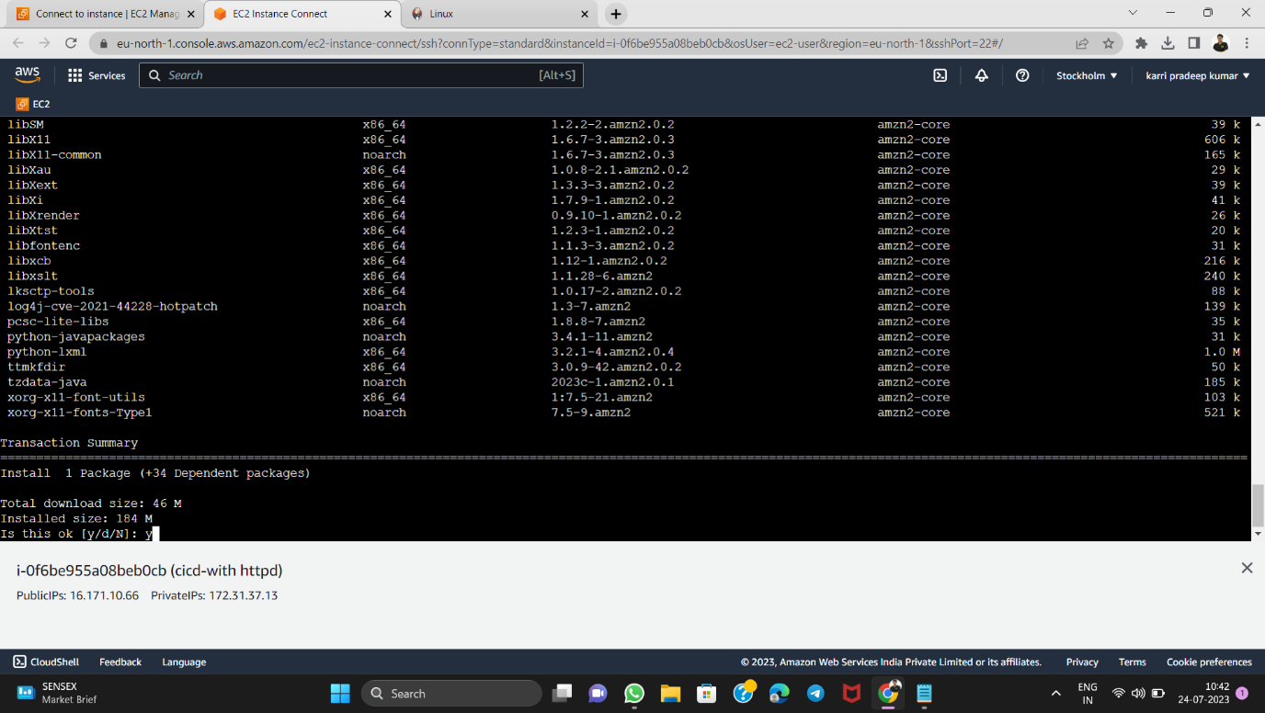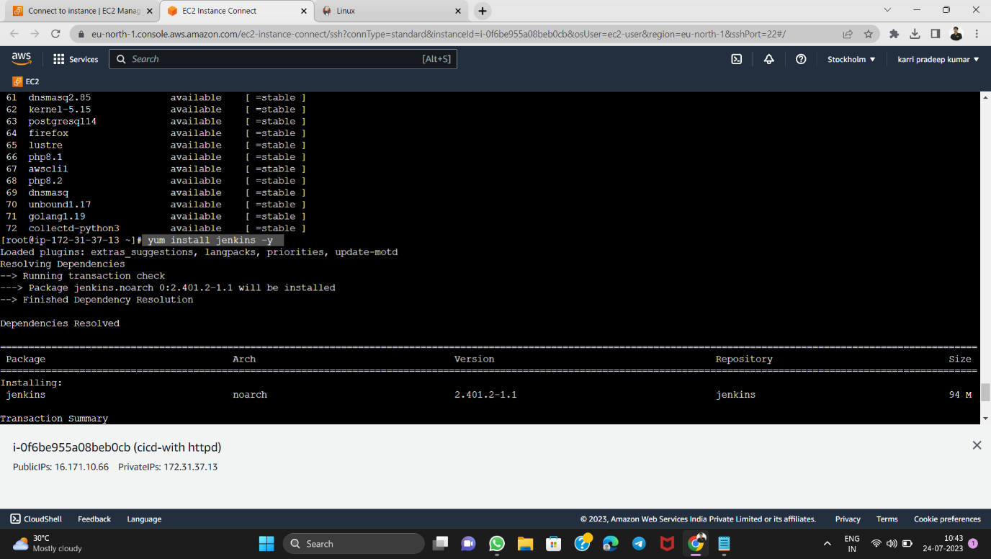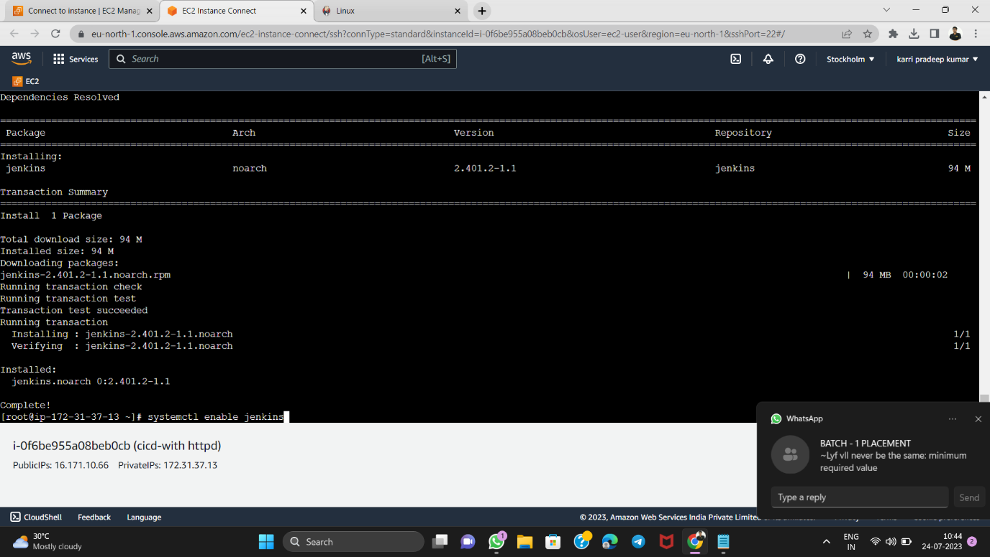

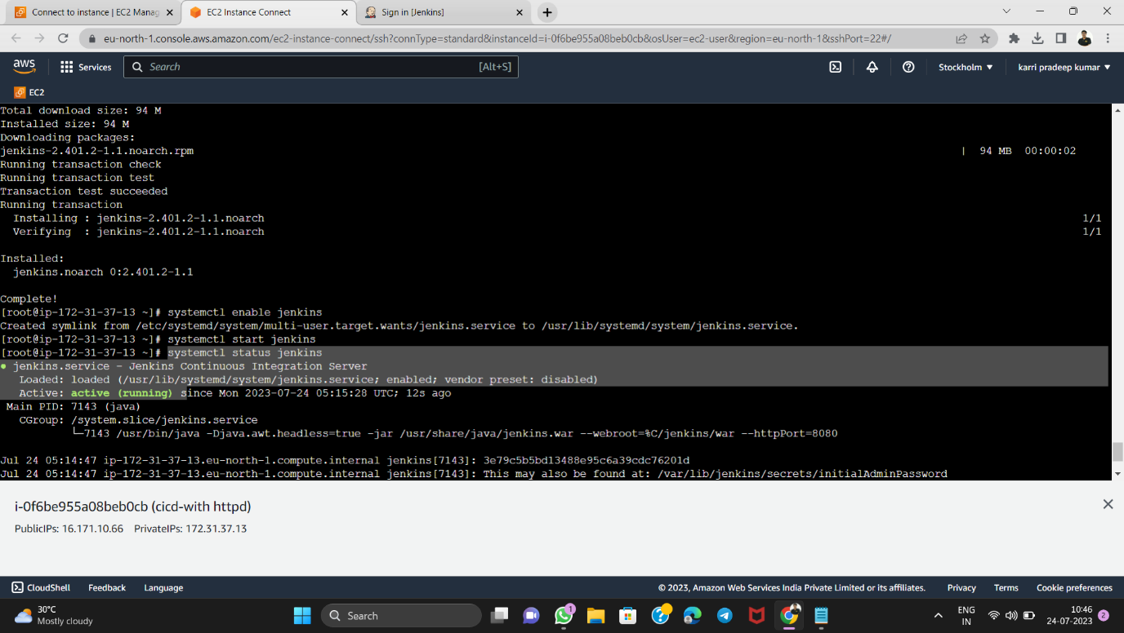

* TO CONNECT THE JENKINS USE PUBLIC IP:8080
* For password
* cat /var/lib/jenkins/secrets/initialAdminPassword

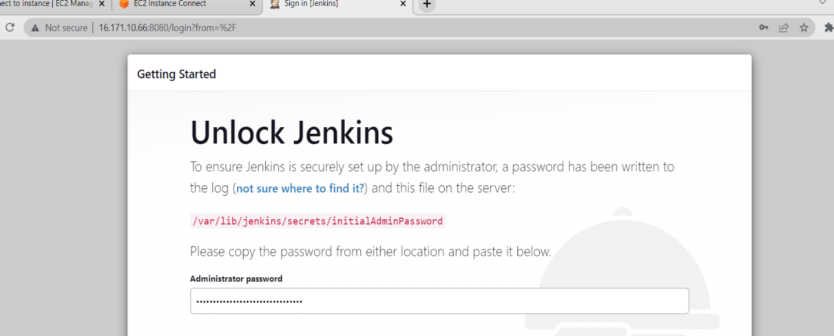

* INSTALL SUGGESTED PLUGINS

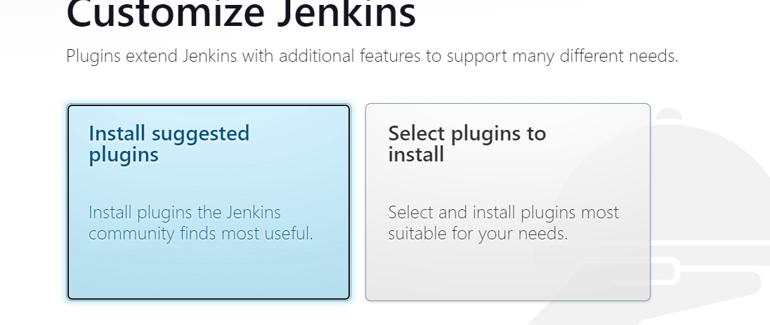

* CREATE A JOB 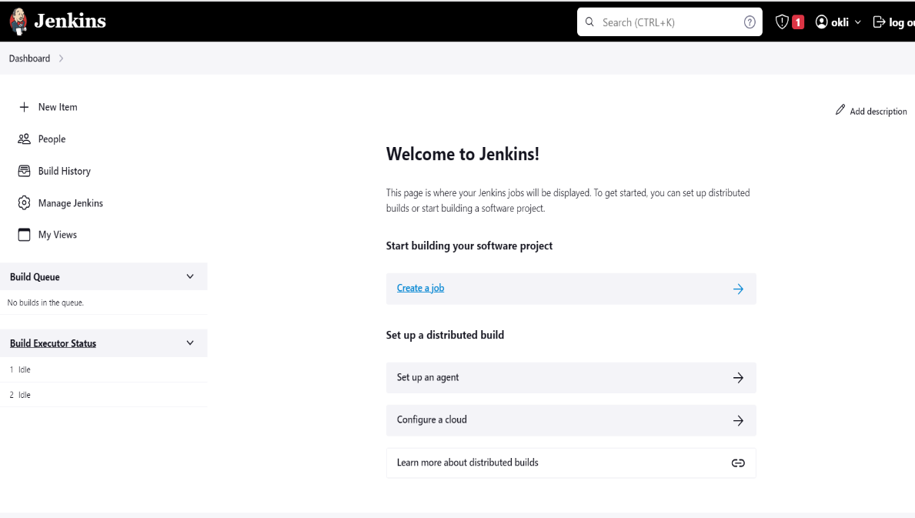
* CREATE USING FREE STYLE PROJECT

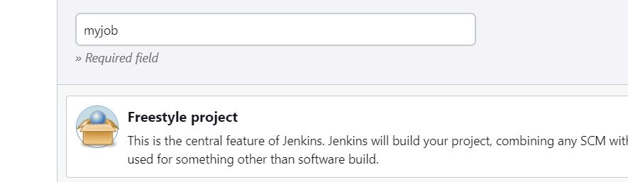

GO BACK TO INSTANCE AGAIN AND INSTALL GIT AND HTTPD

* yum install git -y
* yum install httpd -y
* systemctl enable httpd
* systemctl start httpd
* systemctl status httpd

\*\*\* make sure status is running

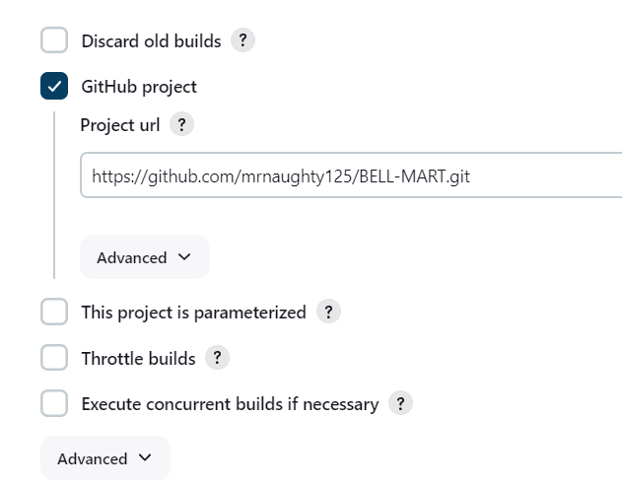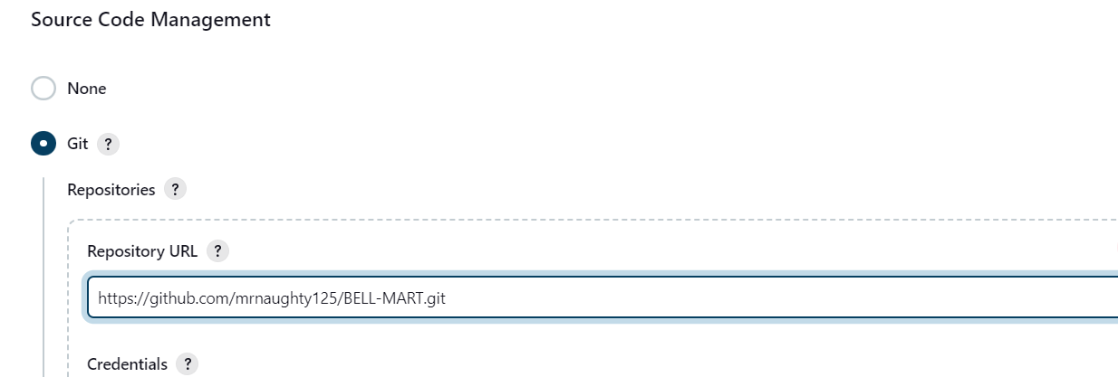

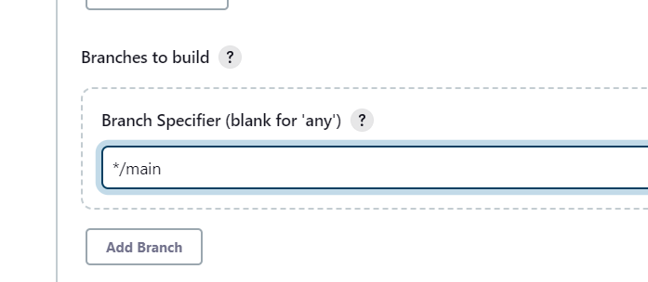



AGAIN TO CONFIGURE

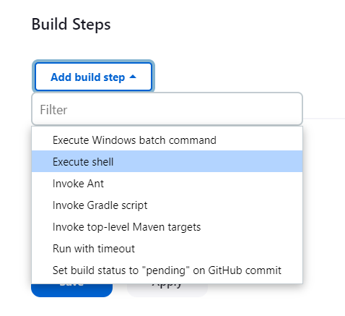

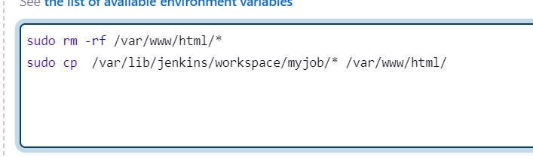

MAKE A BULID AGAIN



For auto bulid in the change in github using POLL-SCM

Again go to configure and make some additions

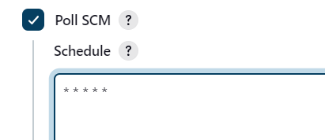

Build again once and see any errors





Before change in github the website looks :



Lets make some change in git hub code the next build will perform automatically hence the CD performed here for CI.



The auto build is done after one minute because the poll scm is \* \* \* \* \* it means for change of the code in github after one minute it reflects to the website.

The change in website after auto bulid:

